Neogov Requisition - How to Sheet
The purpose of this document is to provide instructions to City departments on how to request candidates from the Targeted Local Hire Program, the Bridge to Jobs Program and/or the Alternative Pathway for Part-Time/Exempt Employees for hiring consideration.

Step 1: Log into Neogov and create a new requisition.

Step 2: Enter your Department/Division

Step 3: Enter either of the following for “Class Spec”
- For the Targeted Local Hire Program, enter: TARGETED LOCAL HIRE PROGRAM (9999)
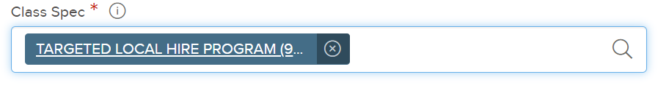
- For the Bridge to Jobs Program, enter: BRIDGE TO JOBS PROGRAM (9999)
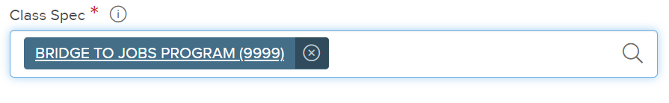
- For the Alternative Pathway for Part-Time/Exempt Employees, enter: ALTERNATIVE PATHWAY FOR PART-TIME/EXEMPT EMPLOYEES (9999)
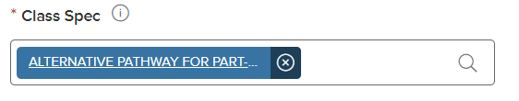
Step 4: Enter either of the following for “Working Title”:
- For the Targeted Local Hire Program, enter either:
  - OFFICE TRAINEE - Targeted Local Hire Program 9999; or
  - VOCATIONAL WORKER (ASSISTANT CLASS) – Targeted Local Hire Program 9999
    - Example: VOCATIONAL WORKER CUSTODIAL SERVICES ASSISTANT - Targeted Local Hire Program 9999
- For the Bridge to Jobs Program, enter “ Bridge to Jobs Program 9999 - TITLE OF TRAINEE CLASS
  - Example: “Bridge to Jobs Program 9999 - Accounting Clerk Trainee”
  - Important Note: For all regular, civil service requisitions only: Copy and paste the class title from the class specs without the class code.
- For the Alternative Pathway for Part-Time/Exempt Employees enter either:
  - OFFICE TRAINEE - Alternative Pathway for Part-Time/Exempt Employees 9999; or
  - VOCATIONAL WORKER (ASSISTANT CLASS) – Alternative Pathway for Part-Time/Exempt Employees 9999
    - Example: VOCATIONAL WORKER CUSTODIAL SERVICES ASSISTANT - Alternative Pathway for Part-Time/Exempt Employees 9999

Step 5: Answer the following standard items:
- Desired Start Date:
- Hiring Manager
  - If a hiring manager is not listed in the drop down list, please submit a request to Certifications at per.certs@lacity.org to add the hiring manager in Neogov.
- Job Type
  - Select Full-Time. Please note that the Targeted Local Hire Program, the Bridge to Jobs Program, and the Alternative Pathway for Part-Time/Exempt Employees are designed to fill full-time, civil service positions.
- List Type
  - Regular
- Number of Vacancies
  - Please enter the number of vacancies. The number of candidates referred will be based on the number of vacancies.
- EEO/Census Data Template
  - May leave blank
- LOCATION
- SHIFT
- Candidate Contact Phone -(213) 555-5555
  - If you would like candidates to report in by telephone, please enter the phone number that candidates should call. If not, please input “999-999-9999” since it is a required field.
- Candidate Contact Email
  - If you would like candidates to report in by email, please enter the email address that candidates should email.

Step 6: Answer the following items that are specific to requisitions for the Targeted Local Hire Program, the Bridge to Jobs Program, and the Alternative Pathway for Part-Time/Exempt Employees. Please note that all items must be answered in order for the requisition to be processed. Failure to provide all information may result in a processing delay.

- IS THIS REQUISITION FOR TLH, BRIDGE, OR ALTERNATIVE PATHWAY FOR PT/EXEMPT EMPLOYEES (APPTE)?
  - YES
  - NO

- Select the appropriate “Trainee” classification for either the TLH, BRIDGE or APPTE Program.
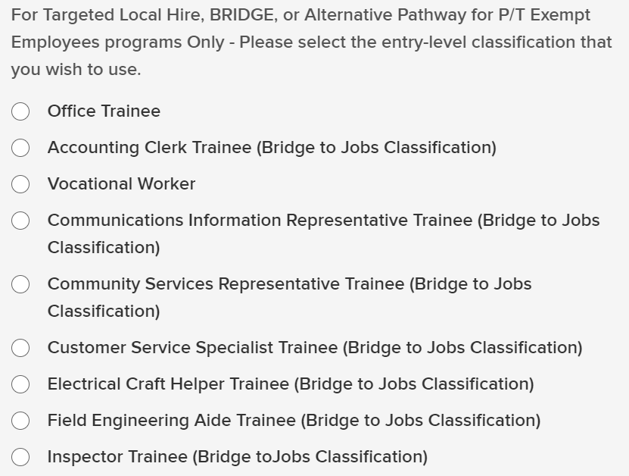
Select the appropriate “Trainee” classification for BRIDGE requisitions.
Select appropriate “Trainee” classification for TLH or APPTE requisitions.

Select appropriate “Trainee” classification for TLH or APPTE requisitions.

- Select the appropriate “Assistant” classification for either the TLH, BRIDGE or APPTE Program.
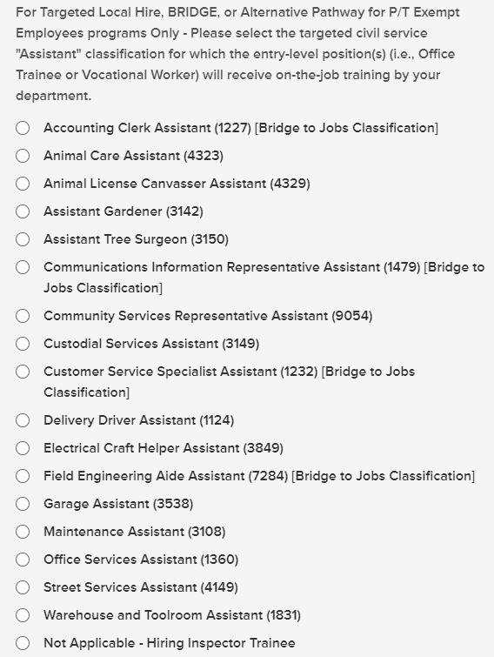
For classes that do not say “Bridge to Jobs Classification,” select the appropriate “Assistant” class for TLH or APPTE requisitions.
[Bridge to Jobs Classification]

- Select the geographic location, work environment, and work shift that apply to the position(s).

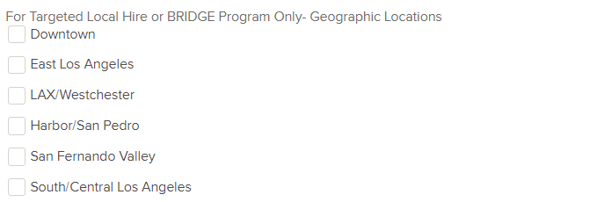
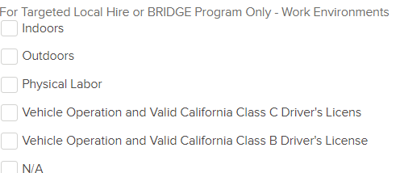
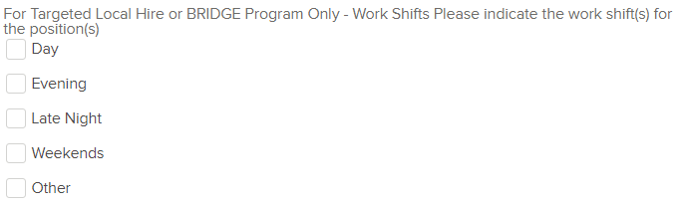

- Enter additional information for TLH, BRIDGE, or APPTE requisitions:
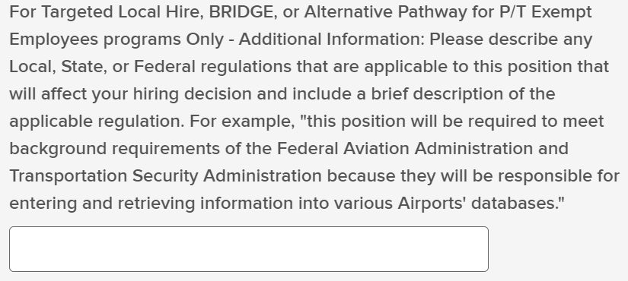
Tell us about specific Local, State, or Federal regulations that apply to this position.
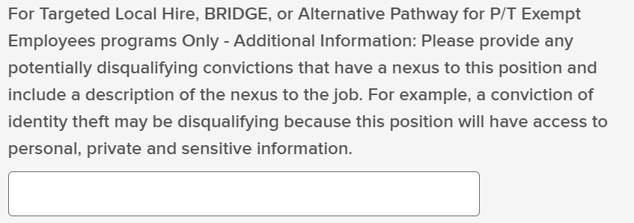
Tell us about disqualifying convictions that may have a nexus to this position.

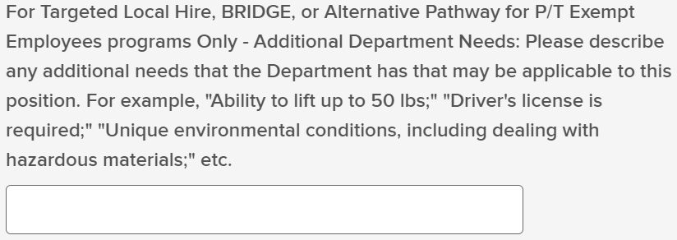
Tell us about any other specific needs that your department has and would like to inform candidates about.

- Enter instructions about how you would like candidates to report in. Please note, candidates submit a short-form application for the TLH, BRIDGE, and APPTE program, which does not include training, education, work or volunteer experience. If you would like to review candidates’ training, education, work or volunteer experience, you may select the option to report in via email and request a resume at the time that candidates report in.
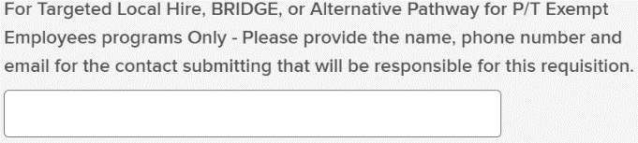
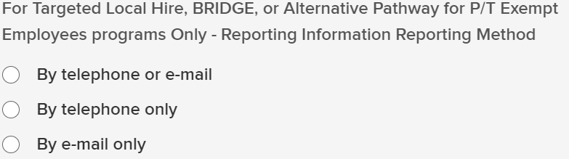
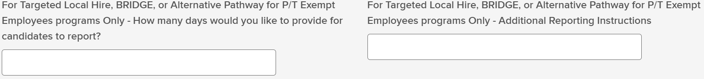

Step 7: Save and Continue to the Next Step.

Step 8: Approval Workflow
New Positions – Classification is no longer needed as an approver. Please only select Personnel LA Local Hire as the approver
All other positions only require Personnel LA Local Hire as approver
- Approval Group: Select “LA Local Hire”
- Approvers: Select “Personnel LA Local Hire”
- Click “Add Approval Step”
- Click “Save and Continue to Next Step”
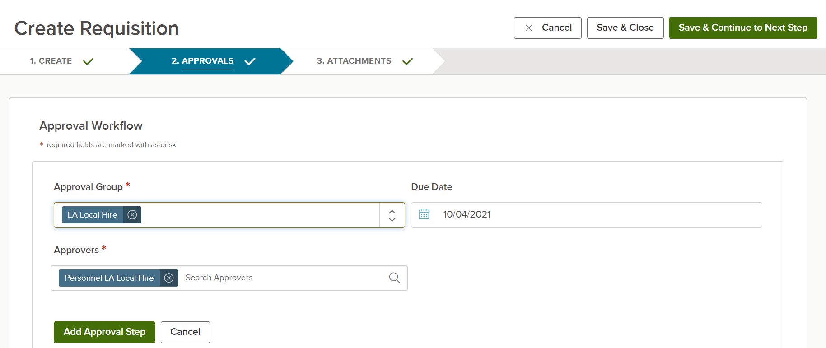

Step 9: Attach position description, if necessary.
- Attach any additional information you feel will be helpful in referring TLH, BRIDGE, and/or APPTE candidates, such as a position description.

Step 10: Select Save and Continue.

