FREQUENTLY ASKED QUESTIONS

- What is LA Local Hire?
“LA Local Hire” refers to the efforts made by the City of Los Angeles to create alternative pathways into civil service careers by means of on-the-job training. Under LA Local Hire there are two (2) different programs: (1) the Targeted Local Hire Program; and (2) the Bridge to Jobs Program.

- What is the difference between the Targeted Local Hire Program and the Bridge to Jobs Program? The Targeted Local Hire (“TLH”) offers alternative career pathways into entry level civil service careers, while Bridge to Jobs (“BRIDGE”) offers alternative career pathways into semi-skilled civil service careers. Each program has different minimum qualifications.

Who can apply?
All applicants are welcome; however, LA Local Hire performs outreach efforts to recruit individuals from under- served communities that have traditionally faced employment barriers, such as: homeless and formerly homeless; formerly incarcerated individuals, including those on parole or probation; former gang members, including those affected by the City’s Rodriguez Settlement; disconnected, foster, or transition age youth; veterans; residents from zip codes as designated by the Public Works, Bureau of Contract Administration within their Project Labor Agreements, including those with limited English proficiency (LEP) but with proficiency sufficient to take advantage of the Program’s training opportunities; individuals identifying as transgender; individuals with disabilities; and older workers protected under the Age Discrimination in Employment Act of 1967 (ADEA). All applicants must have a valid referral code from a designated Application Site and signed Agency Referral Form from an approved Referral Agency. Those applying to BRIDGE must also meet one (1) of the four
(4) BRIDGE requirements.

- Does the City of Los Angeles require vaccination against COVID-19?
In accordance with Los Angeles City Ordinance 187134, candidates must meet the minimum requirement of being fully vaccinated against COVID-19 or receive an exemption and report their vaccination status prior to being hired by the hiring City department. The ordinance is available at https://clkrep.lacity.org/onlinedocs/2021/21-0921_ord_187134_8-24-21.pdf

What careers are available through the TLH Program?
Individuals hired through the TLH Program will be hired as either a Vocational Worker or an Office Trainee and receive six (6) months of on-the-job training (OJT). After successfully completing the OJT, individuals will transition into one (1) of the “Assistant” careers shown below where they will serve six (6) months of probationary period. If individuals successfully complete the probationary period, they will become permanent civil service employees in the targeted full civil service career they trained.

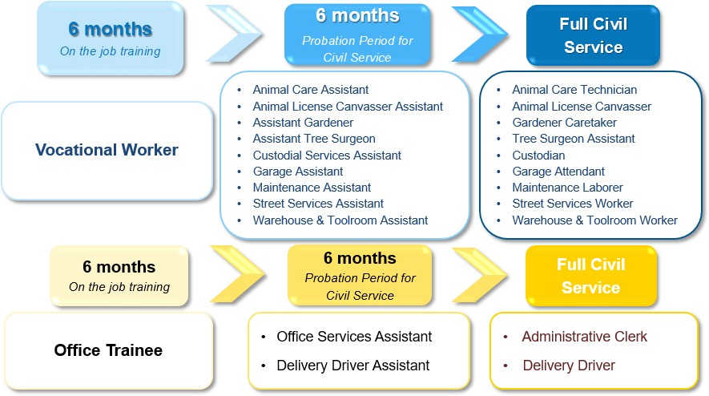
For more information on the duties and responsibilities for each of the careers listed below, please visit https://lalocalhire.lacity.org/resources

What careers are available through BRIDGE?
There are currently two career paths available through BRIDGE: Communications Information Representative (“CIR”) Trainee and Inspector Trainee. If hired as a CIR Trainee, individuals will receive six (6) months of OJT. Upon successful completion of the OJT period, individuals will transition to CIR Assistant, where they will complete a six-month probationary. After successfully completing the probationary period, individuals will transition to the permanent civil service career of CIR. Individuals hired as an Inspector Trainee will receive five (5) years of OJT; however, in order to become a permanent civil service employee, individuals will have to take and pass a civil service examination for “Inspector”. Upon being hired as an Inspector Trainee, individuals may be required to furnish an automobile, properly insured for City service. Mileage will be paid according to established rates. For more information on the duties and responsibilities for each of the careers listed below, please visit https://lalocalhire.lacity.org/resources.

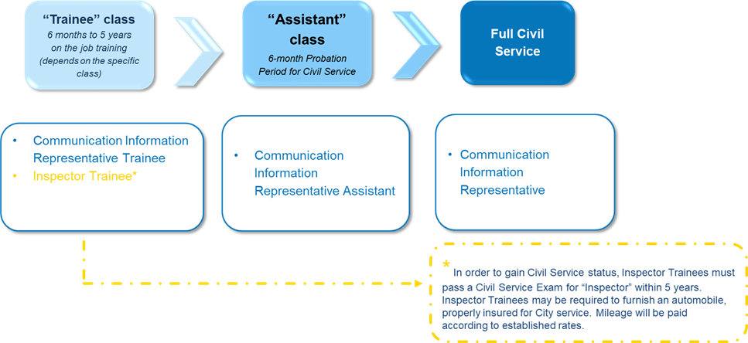

What is the starting pay?
The starting pay for each career path will vary, but the starting pay for careers in the TLH program will be at least
$15.00 per hour or higher with benefits. The starting pay for careers in the BRIDGE program will also vary but will be at least $18 per hour with benefits. Please confirm the salary and benefits with the hiring department before accepting a job offer.

What are the minimum qualifications for the TLH Program?
The TLH Program has no minimum work experience or education requirements. The only requirement for the TLH Program is to be deemed job ready by an approved Referral Agency. If deemed job ready by a Referral Agency, you will receive a TLH Referral Form and will be referred to an Application Site for an LA Local Hire Program Orientation and Application Session. Once you complete the LA Local Hire Program Orientation, you will be issued a unique referral code, which is required in order to submit the TLH Program application. For a list of Referral Agencies and Applications Sites, please visit the LA Local Hire website at lalocalhire.lacity.org. In addition, candidates must meet the minimum requirement of being fully vaccinated against COVID-19 or receive an exemption and report their vaccination status prior to being hired by the hiring City department. The ordinance is available at https://clkrep.lacity.org/onlinedocs/2021/21-0921_ord_187134_8-24-21.pdf

What are the minimum qualifications for BRIDGE?
Similar to the TLH Program, individuals interested in applying to the Bridge to Jobs Program will need to go through a job readiness assessment and obtain a BRIDGE Agency Referral Form before making an appointment at an Application Site to attend a LA Local Hire Program Orientation and Application Session, where they will obtain a valid referral code. However, in addition to the Agency Referral Form and referral code, individuals interested in BRIDGE must meet one (1) of the following four (4) requirements:

- A high school diploma or equivalent; or
- A certification approved by the City of Los Angeles for a specific job pathway in BRIDGE; or
- A qualifying score on the CASAS test administered by the Los Angeles Unified School District Division of Adult and Career Education (“LAUSD DACE”); or
- A qualifying score on the aptitude test administered by the City of Los Angeles, Personnel Department.

Please note that individuals who meet Requirement No.1 or Requirement No. 2 must submit proof of their high school diploma (or equivalent) or proof of their certification to the Application Site on the day that they attend their LA Local Hire Program Orientation and Application Session. Individuals who meet Requirement No. 1 or Requirement No. 2 will not have to take the CASAS test or the aptitude test administered by the City of Los Angeles.

Individuals who wish to take the CASAS test described in Requirement No. 3 or the aptitude test described in Requirement No. 4 may choose either of these options on their BRIDGE online application. After submitting the BRIDGE online application, individuals will receive an email with information regarding their test date and time. Individuals will be invited to take the test in the order that their application was received.

In addition, candidates must meet the minimum requirement of being fully vaccinated against COVID-19 or receive an exemption and report their vaccination status prior to being hired by the hiring City department. The ordinance is available at https://clkrep.lacity.org/onlinedocs/2021/21-0921_ord_187134_8-24-21.pdf

Can I apply to both programs?
Yes, you may apply to both programs as long as you meet the minimum requirements for each.

How do I apply?
Step 1: Visit a Referral Agency approved by the City of Los Angeles (for a list of approved Referral Agencies, please go to https://lalocalhire.lacity.org/where-apply). The Referral Agency will give you an overview of both Targeted Local Hire and Bridge to Jobs and asses you for job readiness. If deemed job ready, you will be provided with an Agency Referral Form for the appropriate program. You will keep the original Agency Referral Form and a copy will be emailed to the Application Site of your choice. There are sixteen (16) Application Sites where you may schedule a LA Local Hire Orientation & Application Session for the Program after you have obtained a valid Agency Referral Form.
Step 2: Call the Application Site, and: (1) confirm that the Application Site received your Agency Referral Form that was emailed by the Referral Agency, and (2) schedule an appointment for a LA Local Hire Program Orientation & Application Session and ask the Application Site if you need any additional documents on the day of your appointment. Please remember to take your original Agency Referral Form with you on the date of your appointment. If you are interested in BRIDGE and have a high school diploma (or equivalent) or an approved certification, please bring this to your appointment.
Step 3: Attend your appointment at the Application Site and complete the Program Orientation. You will be given a valid referral code and receive help with submitting the online Program application.

I applied for the BRIDGE program. When will I be scheduled to take the CASAS test or the City’s Aptitude Test?
If you chose to take the CASAS test or the City’s Aptitude Test, you will receive an email with information on your scheduled test date, time, location, and additional pertinent information. Please be sure to check your email regularly to ensure you do not miss your test date. I applied for the BRIDGE program. What happens if I do not achieve a qualifying score on the CASAS test or the City’s Aptitude Test?
If you do not achieve a qualifying score on the CASAS Test or the City’s Aptitude Test, you will receive an email with your options and additional resources. Some of your options may include, retaking the one of the test, taking another test, or taking a remedial course offered by LAUSD DACE.

How do I get a valid referral code?
Please make an appointment at one (1) of the designated Applications Sites of your choice (make sure to obtain a Referral Form from a Referral Agency first). After completing the Program Orientation, staff at the Application Site will provide you with a valid referral code.

What happens after I apply?
All applications will be reviewed by the City of Los Angeles, Personnel Department for a valid referral code from one of the designated Application Sites. If you applied for the BRIDGE program, your application will also be reviewed to ensure it meets one (1) of the four (4) requirements for BRIDGE. Additionally, if you applied for BRIDGE and chose to take either the CASAS test or the City’s Aptitude Test, you will receive a follow-up email with information. If the application is accepted, you will become part of the candidate pool and be eligible for referral opportunities.

When a hiring department has a vacancy, the candidate pool will be filtered for candidates who match the needs of the department. For example, if “Department X” is hiring a night-time custodian who is expected to work indoors on weekends, then the candidate pool will be filtered to identify all candidates who are interested in custodial work, available to work nights, weekends, and indoors. Of the candidates that match the criteria, a number of candidates will be randomly selected to be referred to the requesting department for hiring consideration. The number of candidates randomly selected will be based on the number of vacancies that the department has. The hiring department will then contact the candidates to schedule the next step, which may include assessments like an oral interview, a performance test, etc. The hiring department will make a hiring decision.

If you are selected, the hiring department will make you a conditional job offer (subject to background review and medical clearance). If you are not selected, your name will be returned to the candidate pool and you will be eligible for other referral opportunities. If the department takes longer than 30 days to make a decision, we will also make you available for additional opportunities while they continue to consider you.

Your application is active for one (1) year (or until you are hired). Should you wish to renew your application after the year, simply follow the instructions in the email renewal notice that will be sent to you approximately one month before your application expires.

Please contact the Personnel Department for questions about the referral procedures.

When will I be referred?
The referral process is based on the needs of the hiring departments and by random selection; as such, there is no promised timeframe or even guarantee that you will be referred. Please check your email account daily to ensure that you do not miss any opportunities. Once referred to a department, you will need to respond as soon as possible to let the department know you are interested in the position or you will not be considered.

What if I need a job now?
LA Local Hire does not guarantee a job. If you need immediate work, we encourage you to seek and accept other employment opportunities. You will continue to be eligible for referral opportunities with LA Local Hire even if you have accepted a job elsewhere. For help finding other employment opportunities, we recommend signing up for additional career services at a WorkSource Center or with one of our Referral Agencies.

- What if I get a job somewhere else?
You may remain in the candidate pool and eligible for referral opportunities even if you are currently employed elsewhere. LA Local Hire simply offers you an additional chance to report for referral opportunities with the hiring department when randomly selected. If you are no longer interested, please notify the Program staff. Please do not rescind any other job offers or quit an existing job until you have actually started working at a department. Please remember that being referred to a hiring department is an opportunity to be considered for a job; however, it does not guarantee a job.

What if my application expired but I want to continue to participate?
Each application is active and valid for referral opportunities for a period of one (1) year. Approximately one month before your application expires, you will receive an email notification and be asked to click a button to renew your application. Once you indicate you would like to renew your application, it will be renewed for another year. If your application has already expired, contact your Referral Agency or Application Site to submit a new application.

What if I need to update my application?
If you need to update contact information only (address, phone number, email address), please sign on to your account at governmentjobs.com to make changes to your master profile. If you need to make changes to your job preferences (for example, desired job type, work location, shift preference, etc.), you will need to complete, sign and submit a Request for Job Preference Update to lalocalhire@lacity.org. The Request for Job Preference Update form can be found at https://lalocalhire.lacity.org/resources.

What if I have a criminal record or conviction?
A background check will be conducted by a hiring department only AFTER a conditional job offer has been made. Having a conviction record does not mean you are automatically disqualified. Please provide all pertinent information on convictions. All convictions will be reviewed in consideration of the specific job offered. It is critical that you are completely transparent and truthful about any conviction because withholding conviction information may be grounds for disqualification.

Each City department and positions within it may be subject to various local, state, or federal laws. If you are not eligible for a particular position, you may still be eligible for other positions in other departments. If you are not hired, you will be returned to the candidate pool and will be eligible for future referral opportunities.

Please contact the Personnel Department if you have additional questions or concerns about background checks.

In accordance with Los Angeles City Ordinance 187134, candidates must meet the minimum requirement of being fully vaccinated against COVID-19 or receive an exemption and report their vaccination status prior to being hired by the hiring City department. The ordinance is available at https://clkrep.lacity.org/onlinedocs/2021/21-0921_ord_187134_8-24-21.pdf

What if I am referred to a department but I am not hired?
If you are not hired after being referred, your name will be returned to the candidate pool and you will continue to be eligible for future referral opportunities, unless you ask to be removed from the candidate pool, you get hired, or your application expires and you choose not to renew it.

Who may I contact if I have any questions or concerns?
Please email LA Local Hire staff at lalocalhire@lacity.org.

